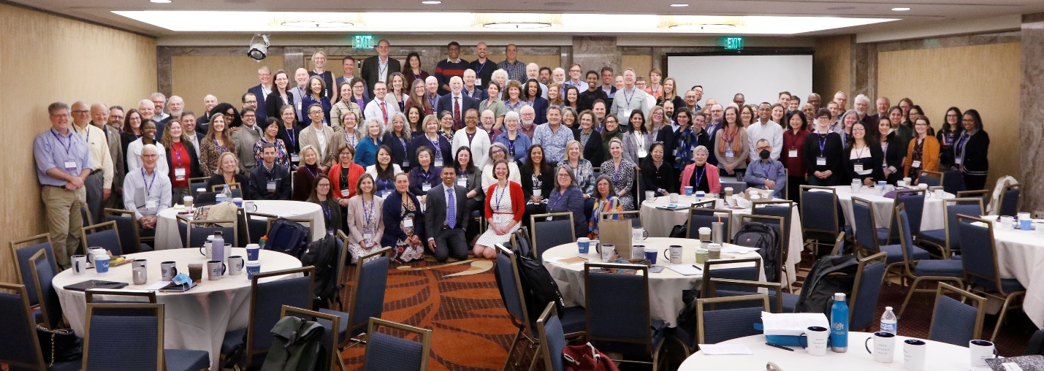
Article Title: Celebrating Our XXX’s Remarkable Contribution to Family Medicine Research
*[Institution Name] Recognizes [Faculty Name]'s Role in Shaping the Future of Family Medicine Research
In a momentous gathering of visionaries, innovators, and leaders in the field of family medicine, [Faculty Name] of [Institution Name] played a vital role in shaping the future of research within the discipline. The National Family Medicine Research Summit, held on October 30, 2023, brought together over 140 distinguished experts who are dedicated to expanding the horizons of family medicine research.
At the heart of this historic event was the collaborative creation of a strategic research plan aimed at revolutionizing the field. The summit embraced innovative approaches, utilizing liberating structures to engage participants fully. This collaborative approach resulted in the development and prioritization of action steps aligned with the objectives outlined in the strategic plan.
Summit Chair, Dr. Irfan Asif, expressed deep appreciation for [Faculty Name]'s exceptional contributions during the summit. "We owe a tremendous debt of gratitude to [Faculty Name] for their invaluable input and dedication to defining our action steps and initiatives. It is through the commitment and expertise of individuals like [Faculty Name] that we can drive this strategic plan toward a brighter future for family medicine research. We eagerly anticipate [Faculty Name or pronoun] continued leadership in spearheading these vital initiatives."
The strategic planning process undertaken by these Family Medicine leaders has crafted a vision for research that is nothing short of transformational. It envisions research that is “whole-person, family, and community centered and improves health by enhancing health promotion, improving care for chronic diseases and advancing healthcare delivery, while including cross-cutting themes of health equity, technology, and team science”.
The blueprint for this vision involves three key strategic priorities:
- Pathways and Mentorship Programming: Creating a robust system to mentor and guide emerging researchers in family medicine.
- Funding and Advocacy Efforts: Ensuring sufficient resources and support for groundbreaking research in the field.
- Infrastructure Development: Building the necessary infrastructure to facilitate cutting-edge research initiatives.
The complete strategic plan can be found here. Additionally, a concise summary of key action steps and communication strategies that will be shared in the coming weeks.
[Institution Name] is immensely proud of [Faculty Name]'s vital role in this historic summit and celebrates [his/her] dedication to advancing the frontiers of family medicine research. We look forward to supporting [Faculty Name] in [his/her] continued journey to bring about positive change in the field of family medicine.

